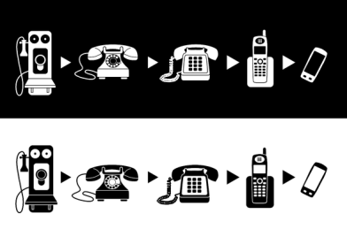

Title Slide
Type your first 3 slides in the following 3 boxes. Run a spell/grammar check for each. When you are done, copy and paste the information into your Movie Maker project.
Title slide-

Technology “Official” Definition Slide
Official definition-

Technology “Simple” Definition Slide
Simple definition-

Introductory Slide
Type your introductory slide below, run the grammar/spell check, then copy & paste it into Movie Maker.

Example- On March 10, 1876, Alexander Graham Bell placed the world’s first telephone call. From that day forward, the telephone has probably been the most important piece of communication technology known to mankind. As time has progressed, the phone has evolved dramatically into a device that not only allows people to communicate but goes MUCH further. This slideshow is intended to inform viewers of some of the major advancements that the telephone has undergone.

(I would use 2 Movie Maker slides for this “Introductory Slide(s).” In general, you do not want too much typing on 1 slide. It should take your reader no more than 5 seconds to read 1 slide.)

Your introduction-

Directions
1) Go on the internet and find facts that go along on with your topic.
2) Copy them from the internet and paste them in the spaces below.
3) Retype those facts, in your own words, in the space below the copied fact.
4) Run a spell and grammar check on your typed fact.
5) COPY (NOT CUT) your retyped facts into Movie Maker.
Copied fact #1-

Fact 1 typed in your words-

Copied fact #2-

Fact 2 typed in your words-

Copied fact #3-

Fact 3 typed in your words-

Copied fact #4-

Fact 4 typed in your words-

Copied fact #5-

Fact 5 typed in your words-

Copied fact #6-

Fact 6 typed in your words-

Copied fact #7-

Fact 7 typed in your words-

Copied fact #8-

Fact 8 typed in your words-

Copied fact #9-

Fact 9 typed in your words-

Copied fact #10-

Fact 10 typed in your words-

Copied fact #11-

Fact 11 typed in your words-

Copied fact #12-

Fact 12 typed in your words-

Copied fact #13-

Fact 13 typed in your words-

Copied fact #14-

Fact 14 typed in your words-

Copied fact #15-

Fact 15 typed in your words-

Conclusion Slide
Example- Phones have come a long way since the day Alexander Graham Bell uttered the words, “Mr. Watson--come here--I want to see you.” This slideshow highlighted some of the major changes the telephone has gone through. Who knows what the future will bring in terms of further changes to the mighty telephone???

Your conclusion-
Credits Slide
Your credits-

