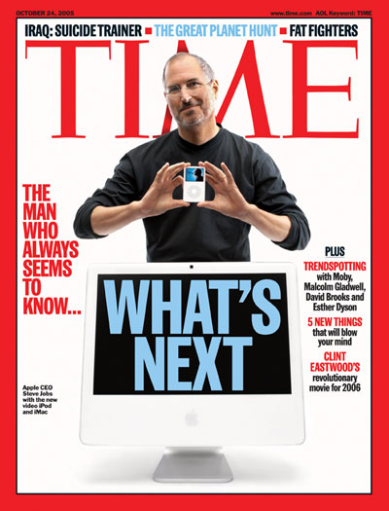
TURN ME IN WHEN YOU’RE DONE!!!
Prompt 1- Steve Jobs helped create the first desktop computer that was affordable enough for many people to purchase and user-friendly enough for most people to use easily.
In a fully developed paragraph, give at least four ways the easy to use and relatively inexpensive personal computer helped change the world.
___________________________________________________
___________________________________________________
___________________________________________________
___________________________________________________________________________________________________________________________________________________________________________________________________________________________________________________________________________________________________________________________________________________________________________________________________________________________________________________________________________________________________
__________________________________________________________________________________________________________________________________________
____________________________________________________________________________________________________________________________________________________________________________________________________________________________________________________________________________________
Prompt 2- One of the most important innovations Steve Jobs helped create was the ipod.
In a fully developed paragraph, explain how the ipod helped change the world. Give at least five ways the music world and the way humans listened to music changed. ________________________________________________________________________________________________________________________________________________________________________________________________________________________________________________________________________________________________________________________________________________________________________________________________________________________________________________________________________________________________________________________________________________________________________
_______________________________________________________________________________________________________________________________________________________________________________________________________________
______________________________________________________________________________________________________________________________________________________________________________________________________________
_________________________________________________________________________________________________________________________________________________________________________________________________________________________________________________________________________________________________________________________________________________________
Prompt 3- Consider all of the innovations that Steve Jobs helped create (personal computers, ipods, iphones, ipads, etc.).
Which innovation do you think had the greatest and most powerful impact on everyday life? In other words, which one changed the world the most? In a fully developed paragraph, defend your choice with at least four justifications. __________________________________________________________________________________________________________________________________________
___________________________________________________________________________________________________________________________________________________________________________________________________________________________________________________________________________________________________________________________________________________________________________________________________________________________________________________________________________________________________
___________________________________________________________________________________________________________________________________________________________________________________________________________________________________________________________________________________________________________________________________________________________________________________________________________________________________________________________________________________________________
___________________________________________________________________________________________________________________________________________________________________________________________________________________________________________________________________________________________________________________________________________________________________________________________________________________________________________________________________________________________________
____________________________________________________________________________________________________________________________________________________________________________________________________________________________________________________________________________________

